Utilization Rate = 100 – ([ Full capacity – Running capacity ]/ Full capacity)*100

Distribution of Demand and Optimized proportion of demand

Un-met Demand

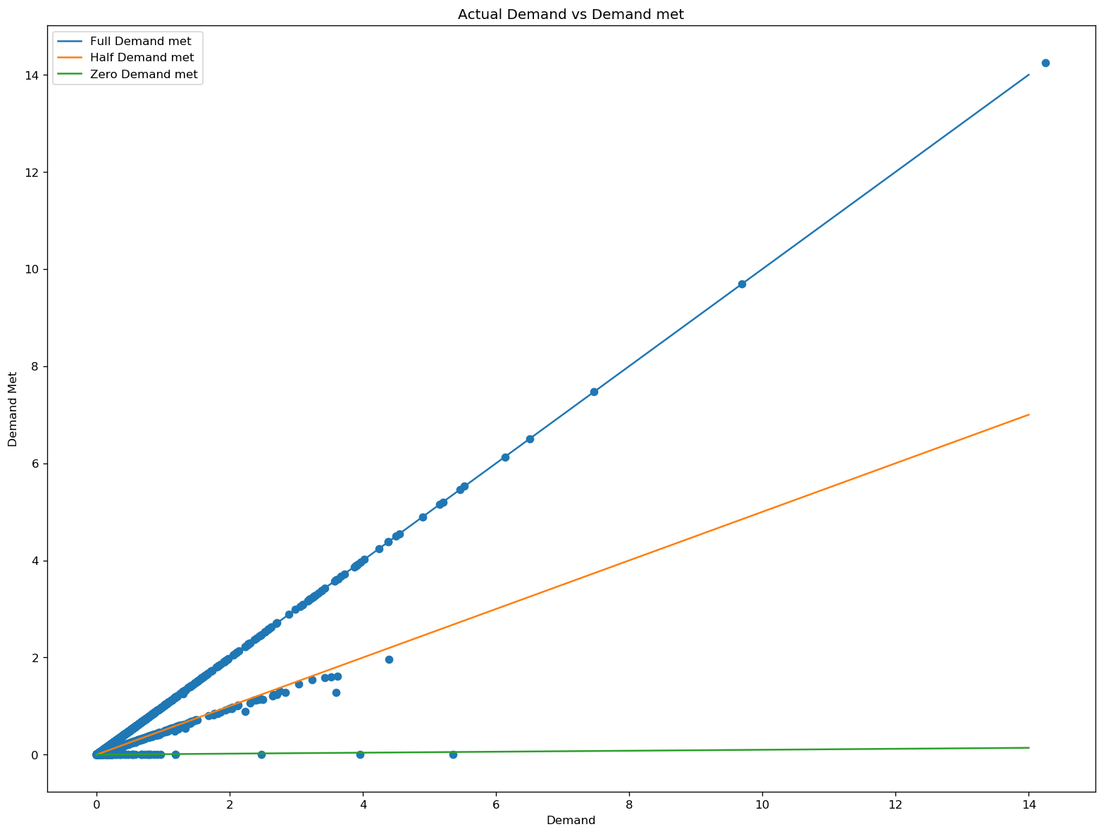

***Results:***

***Top 5 Utilization Results***

Flight Full_capacity Running_capacity Utilization Rate

1 LX0006420020920ZRHMIAC 30.0 30.0 100.0

29 LX0048520020920LCY

BSLC 9.0 9.0 100.0

16 LX0024720020920KHIDXBC 77.0 73.93409 96.0182987012987

2 LX0006420020920ZRHMIAY 120.0 103.6078 86.33983333333333

27 LX0039820020920GCIZRHC 18.0 15.17677 84.31538888888889

***Percentage Demand Met:***

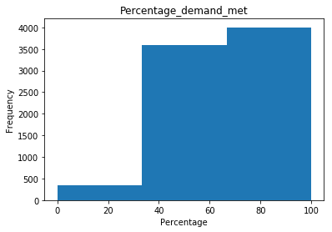

***Summary:***

* LX0006420020920ZRHMIAC , LX0048520020920LCYBSLC are running in full capacity
* Most of the Three flight itinerary demand are not fulfilled

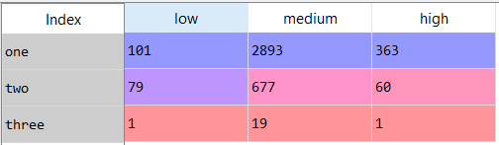

* We can reduce the number of flights in the third category of the itinerary since there are less demand.
* Nearly 342 Flights have been allotted 0 proportion of Demand (rounded of to 5)
* Distribution of the proportion of demand.

